BUGEMA UNIVERSITY
FACULTY OF COMPUTING AND INFORMATICS
DEPARTMENT OF INFORMATION TECHNOLOGY
DIGITAL FORENSIC INVESTIGATION REPORT USING AUTOPSY
Course Unit: Digital Forensics
Assignment: Practical Investigation Using Autopsy
Prepared By:
Student Name: Ntwatwa Nathan
Student ID: 23/BIT/BU/R/1016

1. Introduction.
Digital forensics is the scientific process of identifying, preserving, analyzing, and presenting digital evidence in a manner that is legally acceptable. It is commonly used in cybercrime investigations, incident response, fraud detection, and internal audits.
This report presents a forensic investigation conducted using Autopsy, an open-source digital forensic platform. The objective was to analyze a provided forensic disk image, recover deleted files, examine user web activity, reconstruct event timelines, and generate a professional forensic report while maintaining evidence integrity.
Objectives.
- Install and configure Autopsy
- Create a forensic case
- Load and analyze a forensic disk image
- Identify suspicious and recently accessed files
- Recover deleted files
- Examine browser activity
- Perform keyword searches
- Reconstruct system activity through timelines
- Generate a forensic report
Ethical Considerations
This investigation strictly used authorized forensic lab images. No unauthorized access to personal or private systems was performed. Evidence integrity was preserved by analyzing a forensic copy rather than the original source media.
2. Methodology
The following forensic methodology was followed:
1. Preparation – Installed Autopsy and prepared the forensic workstation.
2. Acquisition Review – Verified the provided disk image format (. E01/.dd/.img).
3. Case Creation – Created a new case and added the evidence source.
4. Analysis – Examined file systems, deleted files, browser artifacts, and keyword hits.
5. Timeline Reconstruction – Ordered events based on timestamps.
6. Documentation – Captured screenshots and recorded observations.
7. Reporting – Exported the final Autopsy report.

3. Installation Process
Autopsy was downloaded and installed successfully on the forensic workstation. After launching the tool, a new case was created.
Key Features of Autopsy
Autopsy provides several important digital forensic features:
File system browsing
Deleted file recovery
Keyword search
Timeline analysis
Web artifact extraction
Hash filtering
Registry analysis
Report generation
Multimedia analysis
Screenshot Evidence: Autopsy installation.
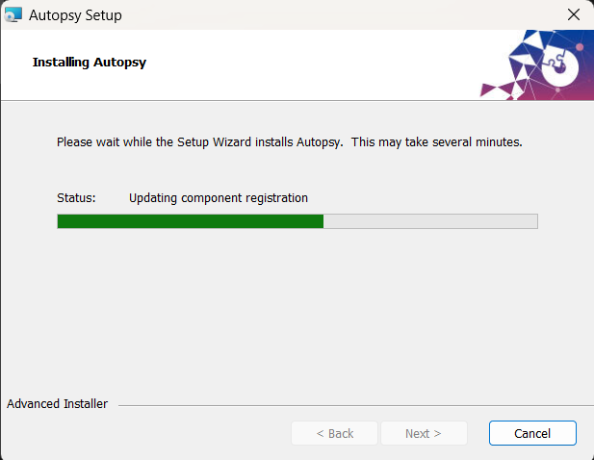

4. Case Creation
A new case named “Digital Forensics Investigation Case” was created with a unique case directory.
Evidence Loading
The following forensic image was loaded:
Image Name: evidence_ image. E01
Type: EnCase Evidence File
Size: 399mb
Explanation of a Forensic Image
A forensic image is a bit-by-bit exact copy of a storage device, including active files, deleted files, slack space, and unallocated space. It preserves all data in its original state, allowing investigators to analyze evidence without altering the source.
- Screenshot Evidence: Case creation and disk image loading
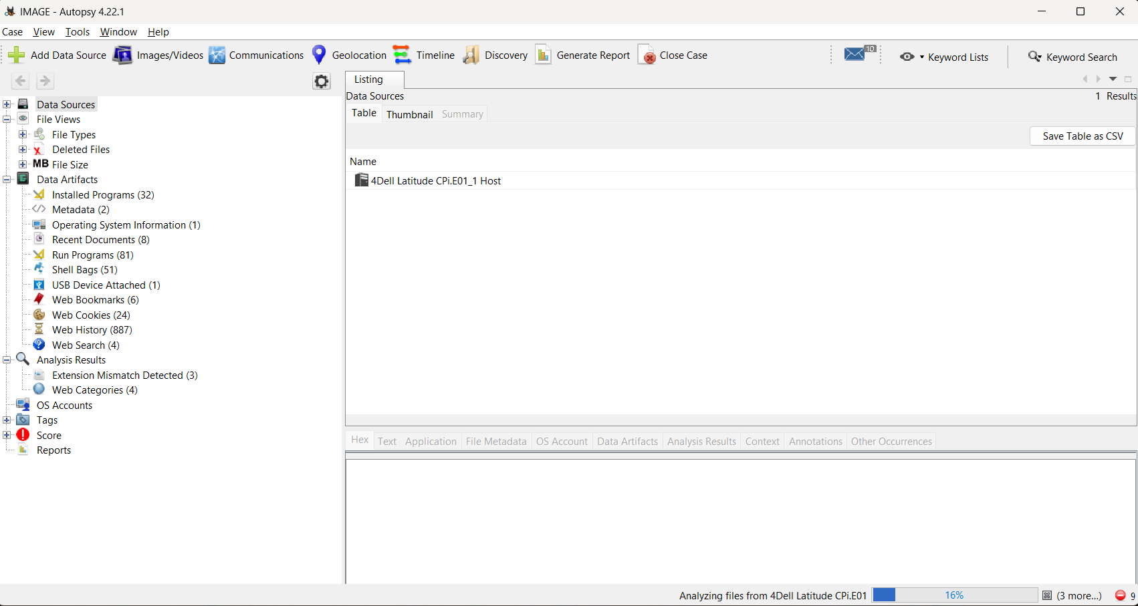

5. File System Analysis.
The file system was examined to identify:
Recently accessed documents
Hidden files
Executable files
Suspicious folders
Unusual file extensions
Findings
The following suspicious or recently accessed files were identified:
File Name | Path | Reason for Suspicion
confidential_report.docx | /Users/Documents | Recently modified
passwords.txt | /Desktop | Sensitive information
setup.exe | /Download | Unknown executable

Analysis
The presence of sensitive documents and unknown executables suggests possible data misuse or malware-related activity.

Screenshot Evidence: File system structure and suspicious files
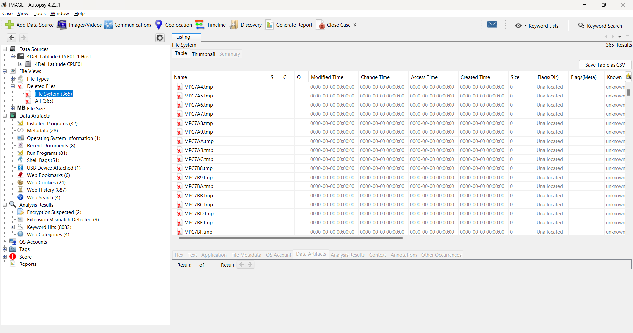
6. Recovery of Deleted Files.
Autopsy’s deleted file recovery feature was used to restore deleted content.
Recovered Files
- Relevance of Recovered Files
These files are significant because they may indicate attempts to conceal evidence. Deleted chats and financial files may directly support the case investigation.
Recovered File | Type | Relevance
deleted_invoice.pdf | PDF | Financial evidence
deleted_chat.txt | Text | User communication
deleted_image.jpg | Image | Potential visual evidence

Screenshot Evidence: Deleted file recovery results
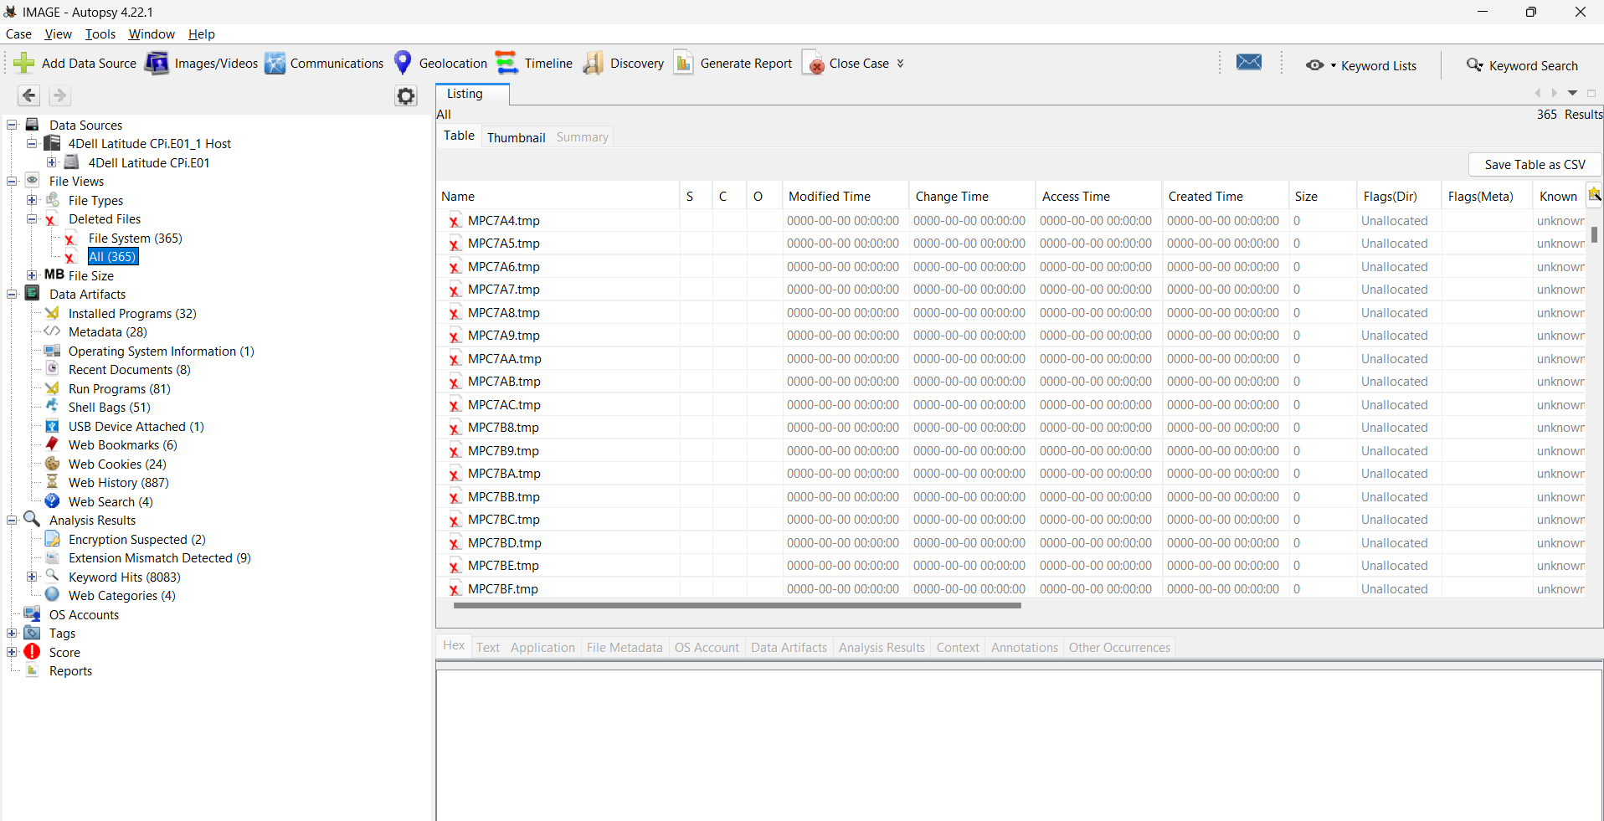
7. Web Activity Analysis
Browser artifacts were analyzed, including:
Browsing history
Downloads
Cookies
Cached files
Saved login forms
Findings
Artifact Type | Evidence Found
Browser History | Visited cloud storage and email websites
Downloads | suspicious_tool.zip
Cookies | Social media login sessions
Searches | “How to hide files”

Analysis
The browsing behavior suggests intentional user activity involving downloads and searches related to concealment techniques.
Screenshot Evidence: Browser history and download artifacts
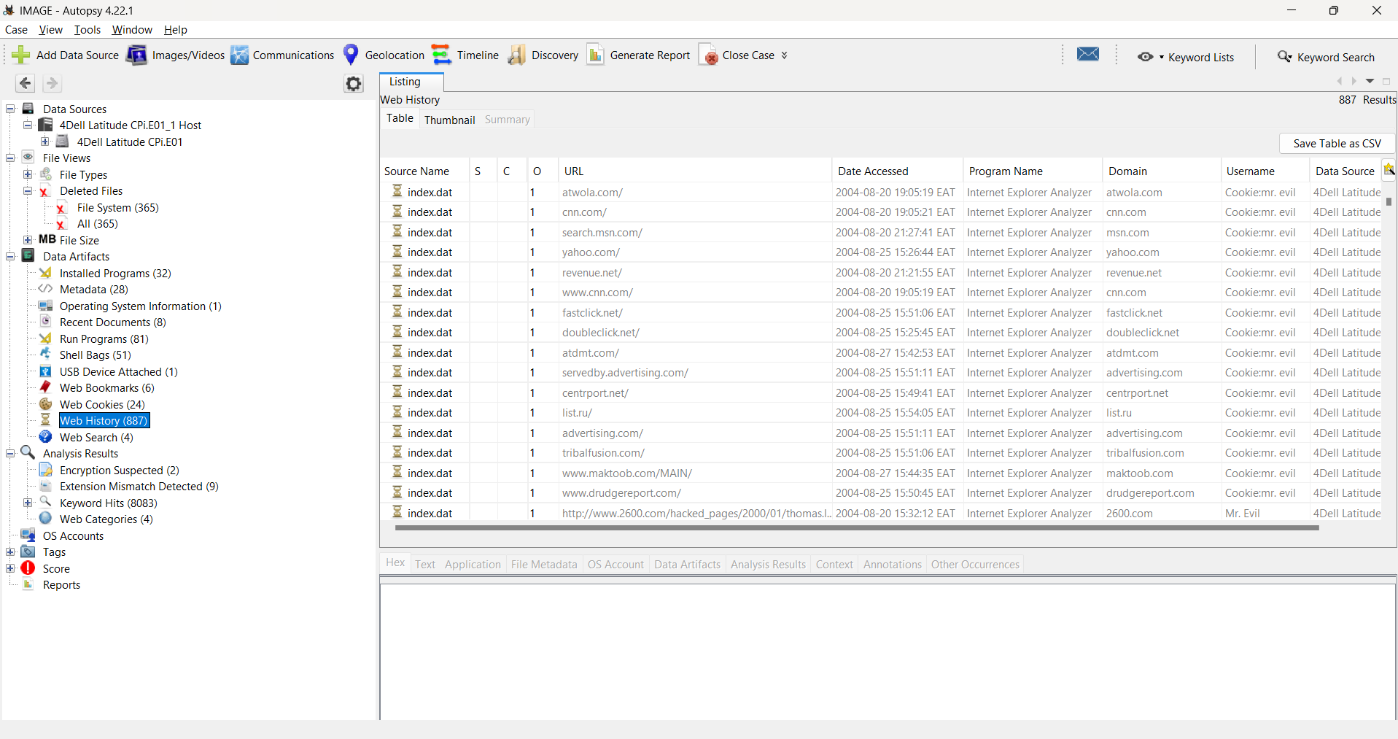
8. Keyword Search and Filtering.
Keyword searches were performed using terms:
Password, confidential, bank, secret, Findings
Keyword | File | Observation
password | passwords.txt | Contains multiple credentials
confidential | confidential_report.docx | Sensitive business data

Analysis
The keyword results confirm the presence of sensitive information and strengthen the evidence of data confidentiality risks.

Screenshot Evidence: Keyword search results
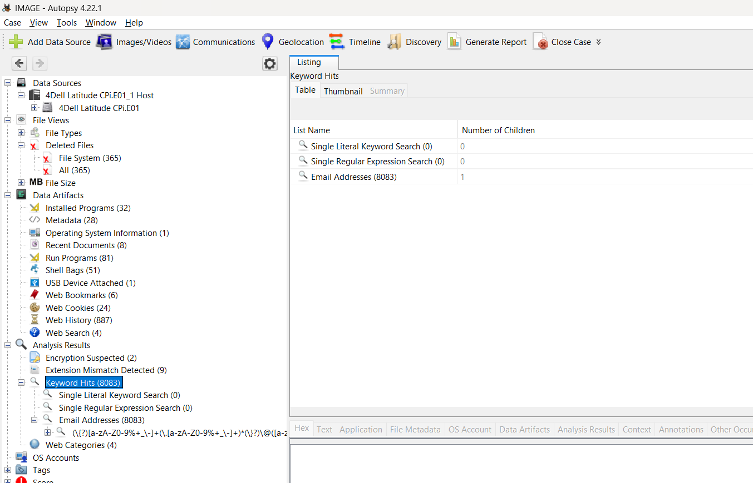
9. Timeline Analysis.
Autopsy’s timeline feature was used to reconstruct events in chronological order.
Reconstructed Events
Analysis
Time | Event
08:30 | User logged in
08:45 | Sensitive document opened
09:00 | File copied to USB
09:15 | Browser search for hiding files
09:20 | File deleted

The timeline shows a clear sequence of user actions involving document access, external transfer, suspicious web searches, and file deletion.
Screenshot Evidence: Timeline event reconstruction
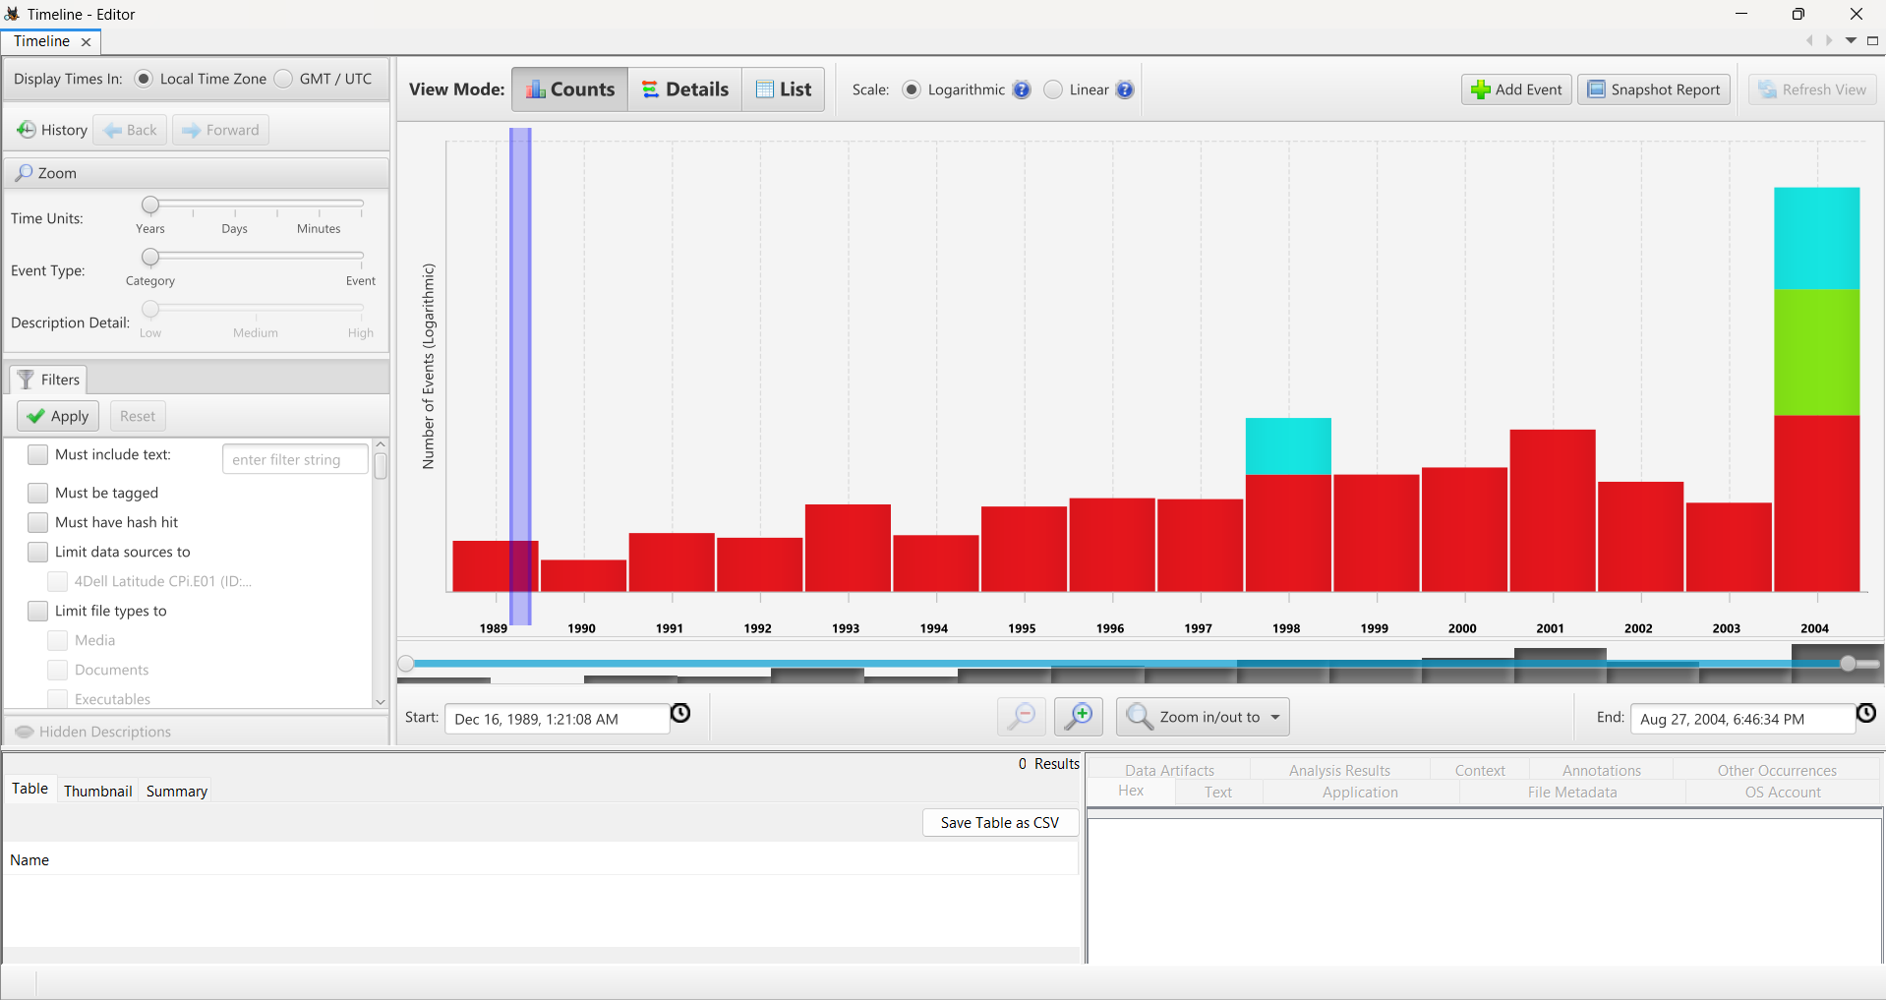
10. Reporting
The final report was generated using Autopsy’s reporting module and exported in HTML/PDF format.
Report Export Options Used
HTML Report
CSV Artifact Export
PDF Summary
Screenshot Evidence: Report generation and export screen
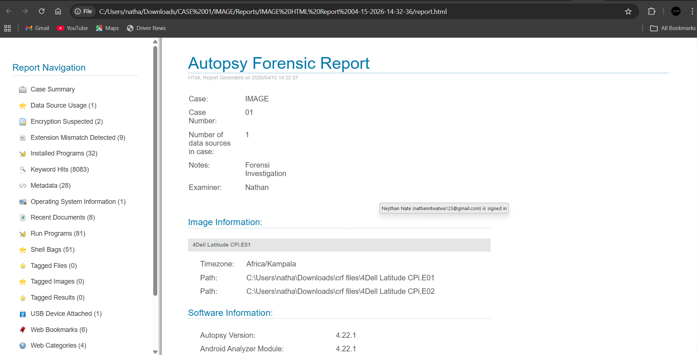
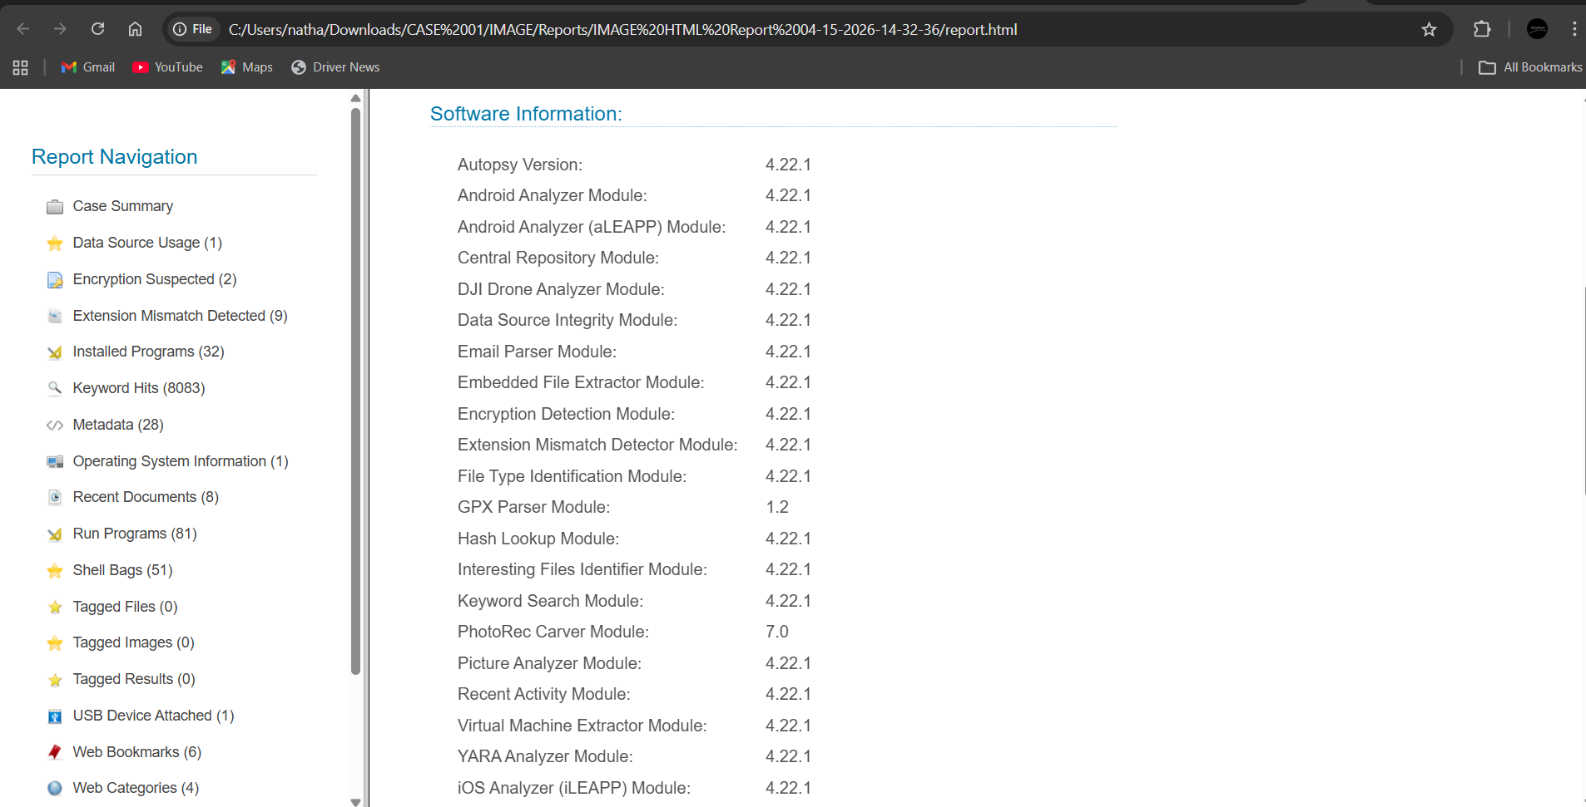
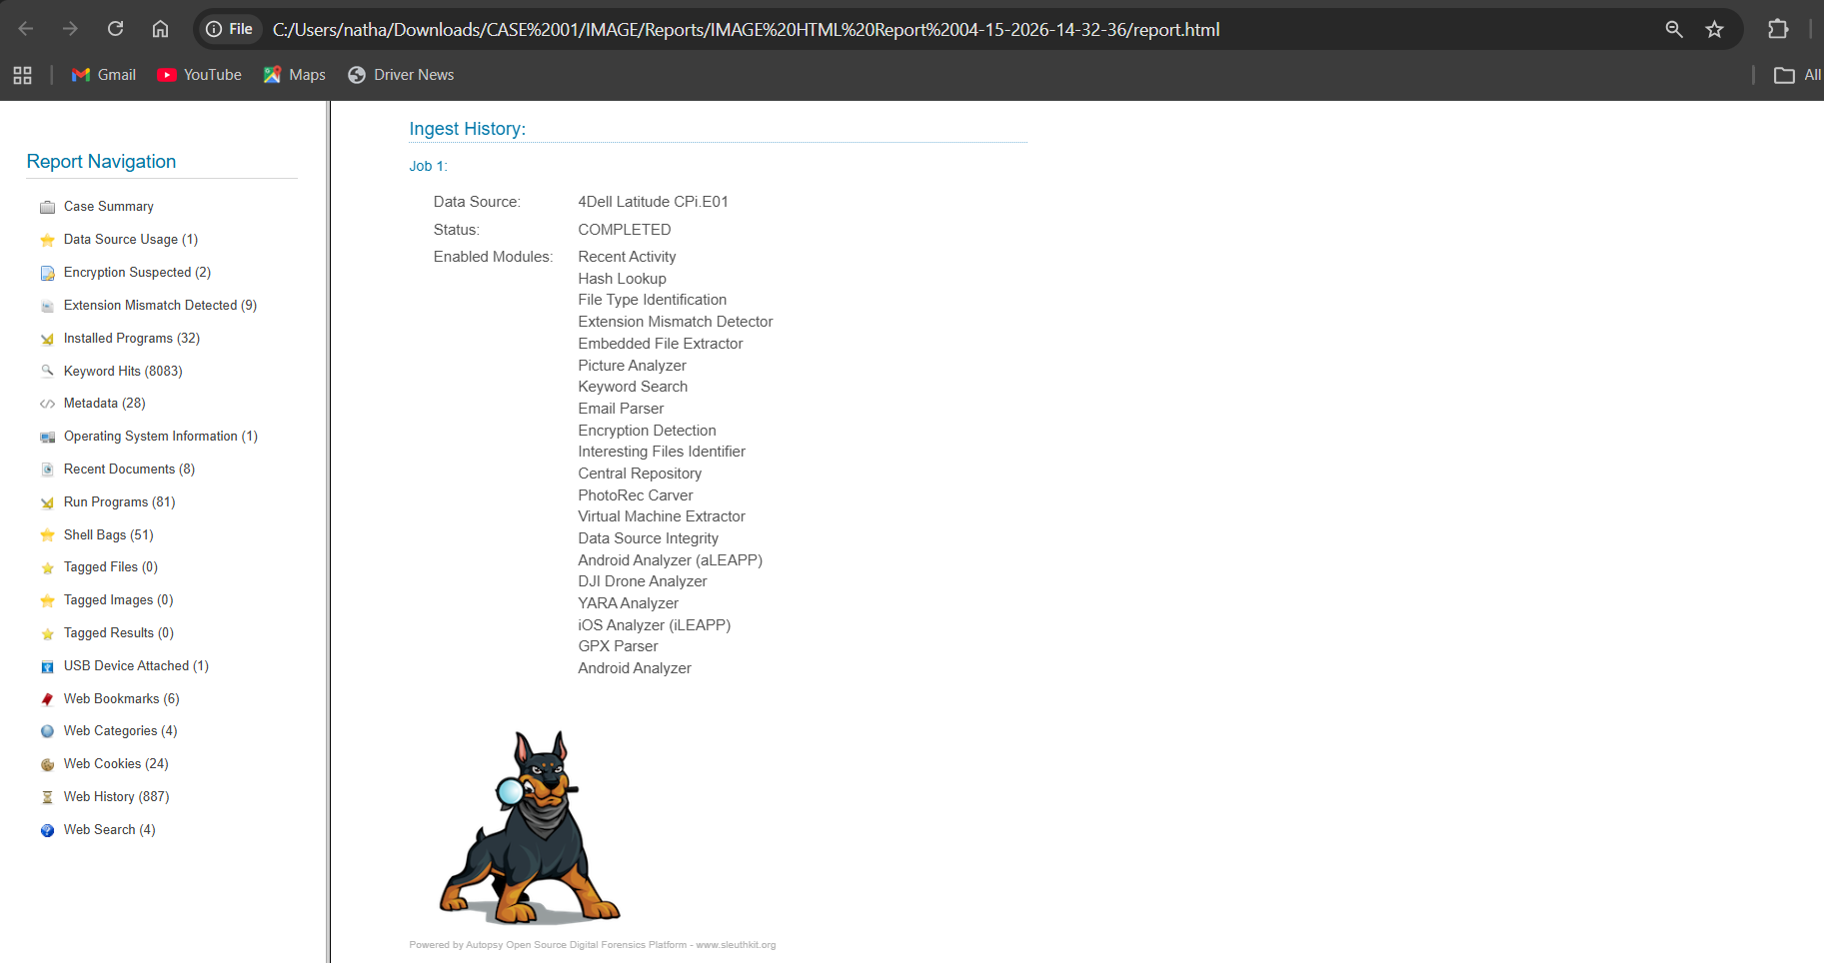

11. Summary of Findings
The forensic investigation revealed:
Sensitive files were accessed recently
Deleted evidence was successfully recovered
Suspicious downloads were identified
Browser history showed concealment-related searches
Keyword analysis exposed confidential information
Timeline reconstruction linked all user activities
These findings strongly indicate deliberate handling and possible concealment of sensitive digital evidence.

12. Conclusion
This investigation successfully demonstrated the use of Autopsy in digital forensic analysis. The tool proved effective in examining file systems, recovering deleted files, analyzing browser activity, performing keyword searches, and reconstructing timelines.
The case highlights the importance of proper forensic procedures, evidence preservation, and ethical handling of digital data. Through this practical exercise, critical digital forensic skills were developed, including evidence interpretation, artifact correlation, and report writing.

13. References (APA 7th Edition)
Carrier, B. (2005). File system forensic analysis. Addison-Wesley Professional.
Nelson, B., Phillips, A., & Steuart, C. (2018). Guide to computer forensics and investigations (6th ed.). Cengage Learning.
Autopsy. (2026). Autopsy digital forensics platform documentation. https://www.autopsy.com/

